Prompt:
You are a QA tester. Based on the attached SRS document, generate a set of simple manual test cases. Each test case should include: Test Case ID, Requirement ID, Title, Steps, and Expected Result. Cover only the main positive (happy path) scenarios.
Summary Report:
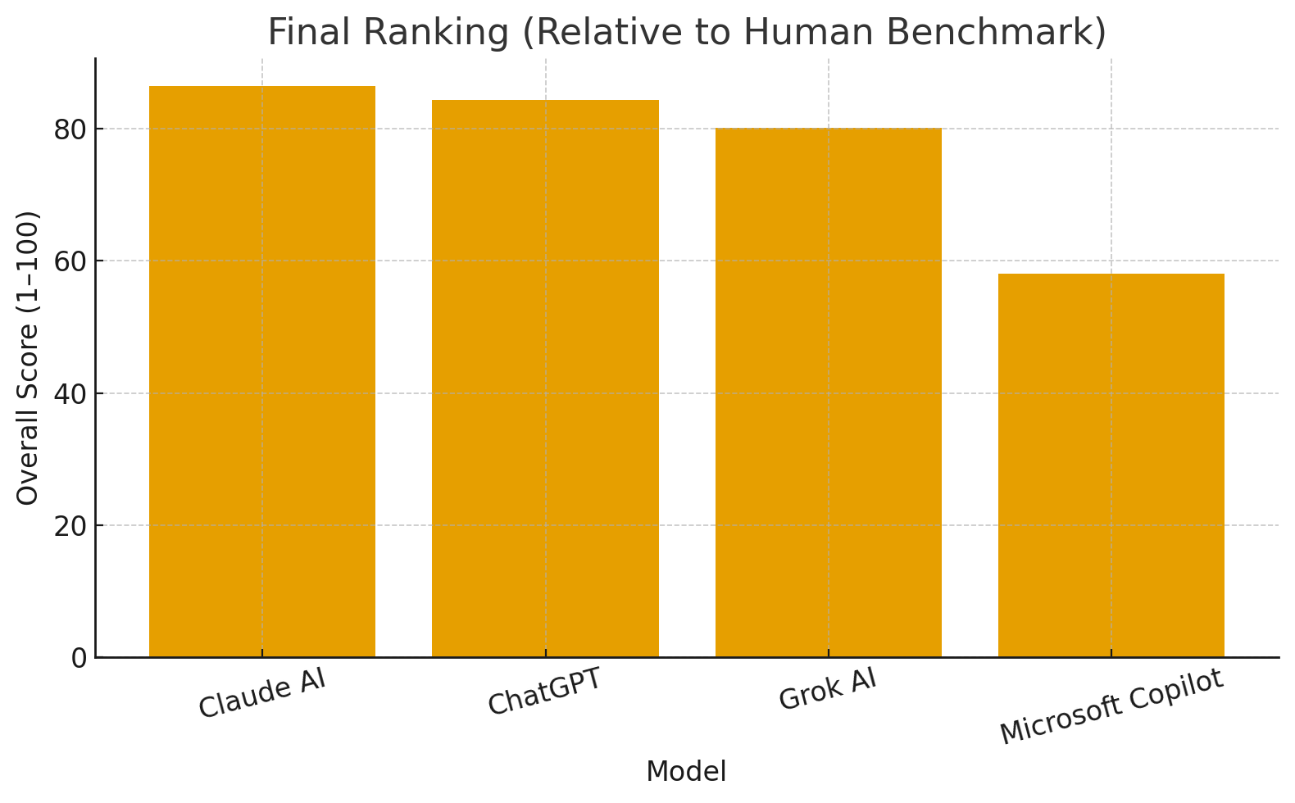
Using the human test set as a 100-point benchmark, I scored each AI model across seven criteria (Accuracy, Completeness, Test Coverage, Efficiency, Quality, Bug Detection, Usability). Overall performance clusters into three tiers:
- Leader: Claude AI (Overall 86.4) strongest alignment to SRS with broad role/flow coverage and clear, maintainable cases; slightly verbose but consistently high quality.
- Strong contender: ChatGPT (84.4) concise, well-structured, with good traceability and domain constraints; coverage a bit narrower than Claude, so slightly lower bug-finding potential.
- Mid tier: Grok AI (80.1) solid structure but lighter on requirement nuances and variation, which trims accuracy/coverage and bug-detection depth.
- Lagging: Microsoft Copilot (58.1) efficient, succinct steps, yet too generic for the domain; misses key flows, hurting completeness, coverage, and bug-detection.

Short answer: Human test cases are better overall.
Why:
- Human > AI on Accuracy, Completeness, Test Coverage, Bug Detection—humans add domain nuances, edge/negative paths, and risk-based scenarios the AIs missed.
- AI > Human mainly on Efficiency (faster, concise, consistent formatting) and decent Usability.
Evidence (relative to human = 100): best AI (Claude AI) averaged 86.4; others trailed (ChatGPT 84.4, Grok 80.1, Copilot 58.1). Humans set the benchmark at 100 across criteria.
Recommendation: Use a hybrid flow—generate a first pass with Claude/ChatGPT for speed and structure, then have a human expand negative/edge cases, tighten traceability to the SRS, and add risk-focused tests before sign-off.

